int floodFill(InputOutputArray image, InputOutputArray mask, Point seedPoint, Scalar newVal, Rect* rect=0, Scalar loDiff=Scalar(), Scalar upDiff=Scalar(), int flags=4 )

* Original image

cv::Mat img = cv::imread("squares.png");

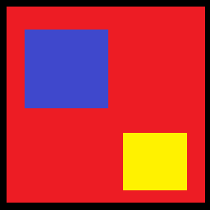

* First variant

cv::floodFill(img, cv::Point(150,150), cv::Scalar(255.0, 255.0, 255.0));

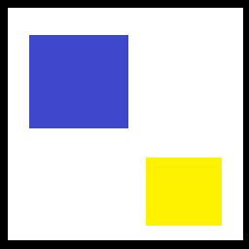

* Second variant

cv::Mat mask = cv::Mat::zeros(img.rows + 2, img.cols + 2, CV_8U); cv::floodFill(img, mask, cv::Point(150,150), 255, 0, cv::Scalar(), cv::Scalar(), 4 + (255 << 8) + cv::FLOODFILL_MASK_ONLY);

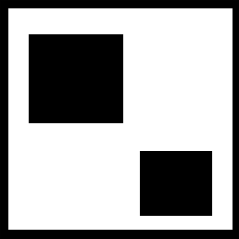 This is the mask. img doesn't change

If you go with this though, note that:

**Since the mask is larger than the filled image, a pixel (x,y) in image corresponds to the pixel (x+1, y+1) in the mask.**